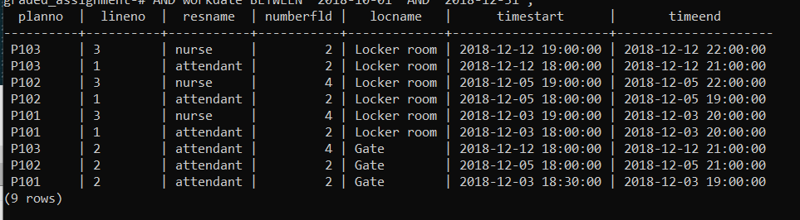

SELECT eventplanline.planno, lineno, resname, numberfld,

locname, timestart, timeend

FROM eventplanline, eventplan, resourcetbl, location,

facility

WHERE eventplanline.planno = eventplan.planno

AND eventplanline.resno = resourcetbl.resno

AND eventplanline.locno = location.locno

AND location.facno = facility.facno

AND facname = 'Basketball arena'

AND activity = 'Operation'

AND workdate BETWEEN '2018-10-01' AND '2018-12-31';